**Table Design**

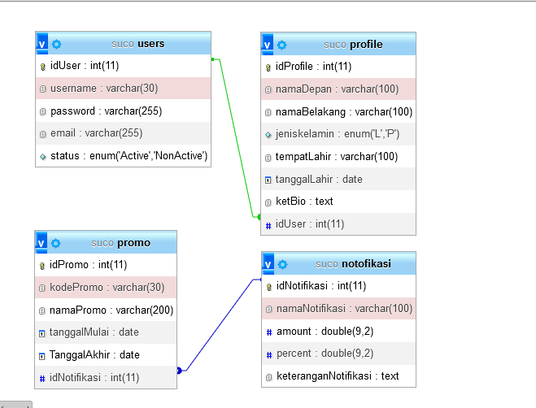­

**Flow Chart**